24 august, 2026
Hard Delete permission is given only to users who have the special permission to permanently delete data.
Permission Set – Bulk API Hard Delete
Step 1: Create Permission Set
- Go to Setup → Permission Sets.
- Click New.
- Enter name: Bulk API Hard Delete.
- License: Salesforce.
- Click Save.
Step 2: Enable Permission
- Open the Bulk API Hard Delete permission set.
- Click System Permissions → Edit.
- Find Bulk API Hard Delete.
- Check/enable it.
- Click Save.
Step 3: Assign Permission Set
- Click Manage Assignments.
- Click Add Assignments.
- Select the required user.
- Click Next → Assign → Done.
Step 4: Perform Hard Delete
- Open Data Loader.
- Select Hard Delete.
- Select the required object and file.
- Execute the operation.
- Verify that the records are permanently deleted.
User Story 1 – Account Records
Step 1: Insert Accounts
- Insert 10 Account records.
- Names: LNCT 1 to LNCT 10.
Step 2: Set Account Details
- Rating = Hot
- Type = Prospect
- SLA = Gold
Step 3: Export Data
- Export Account records matching the conditions.
- Get the Account IDs.
Step 4: Use SOQL
SELECT Id
FROM Account
WHERE Rating = 'Hot'
AND SLA__c = 'Gold'
AND Type = 'Prospect'
Step 5: Hard Delete
- Use the exported Account IDs.
- Perform Hard Delete.
- Verify the records are permanently deleted.

Permission Sets
- Permission Set → gives special features/permissions.
- These permissions are given to a particular user.
- First create the Permission Set.
- Then assign the Permission Set to the user.

Data adding-
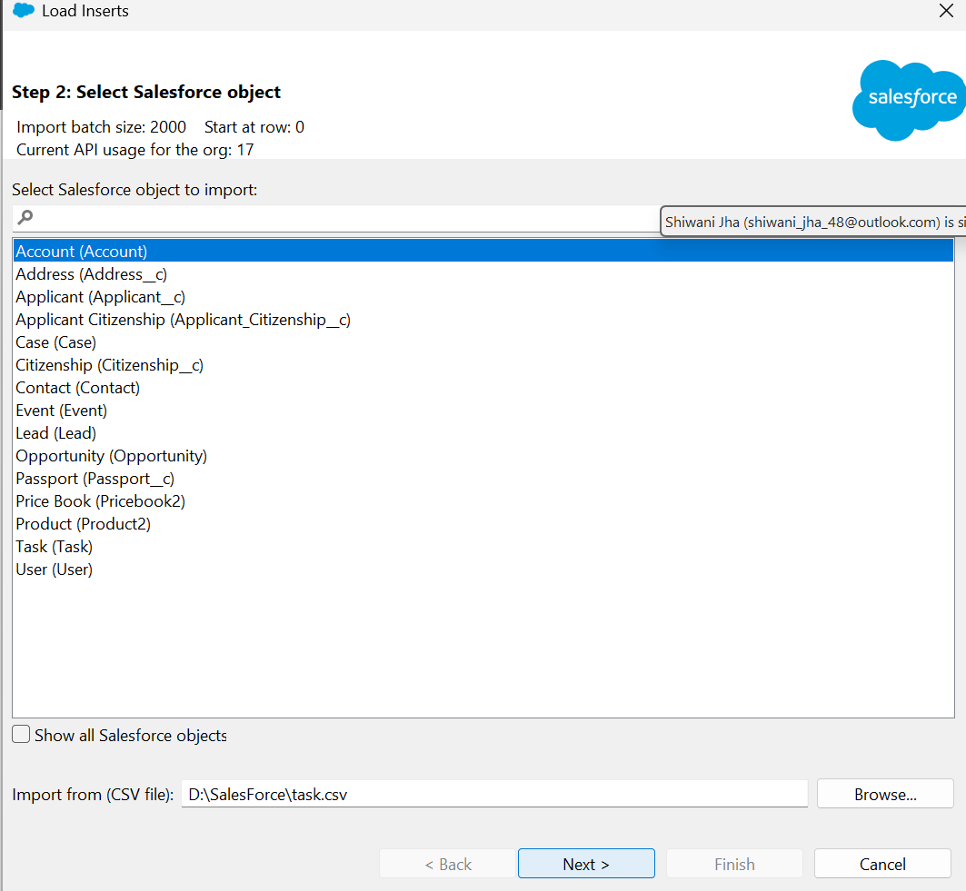
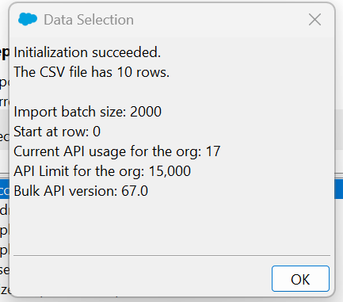
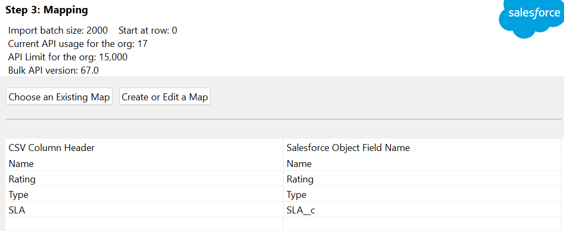
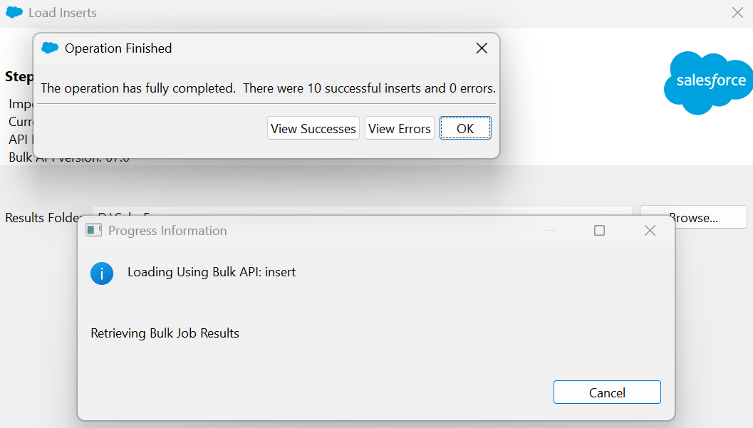
Done
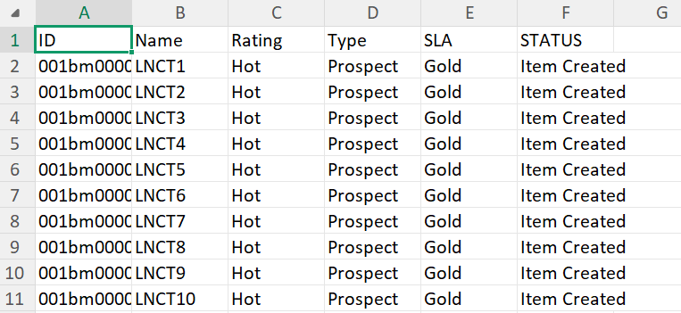
Result-
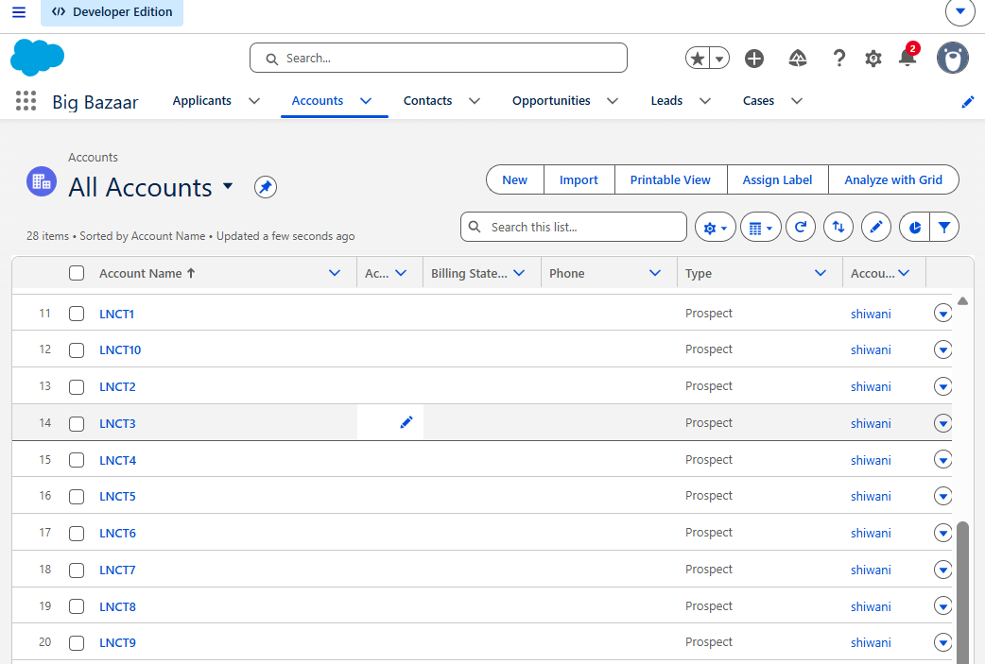

Now let’s extract data of specific conditions-
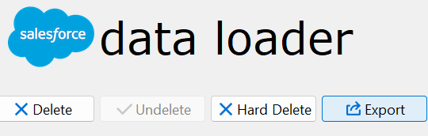
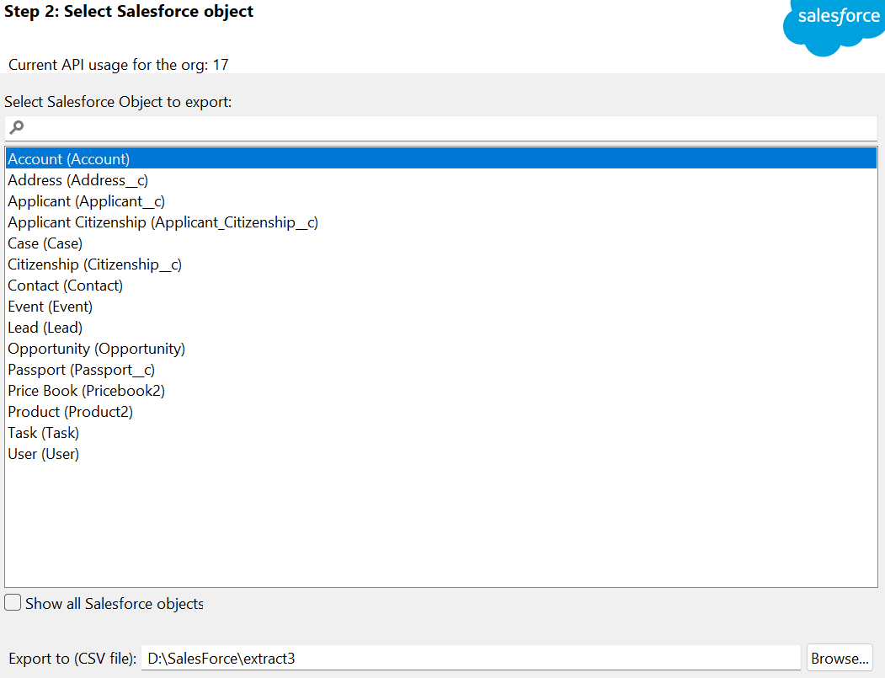
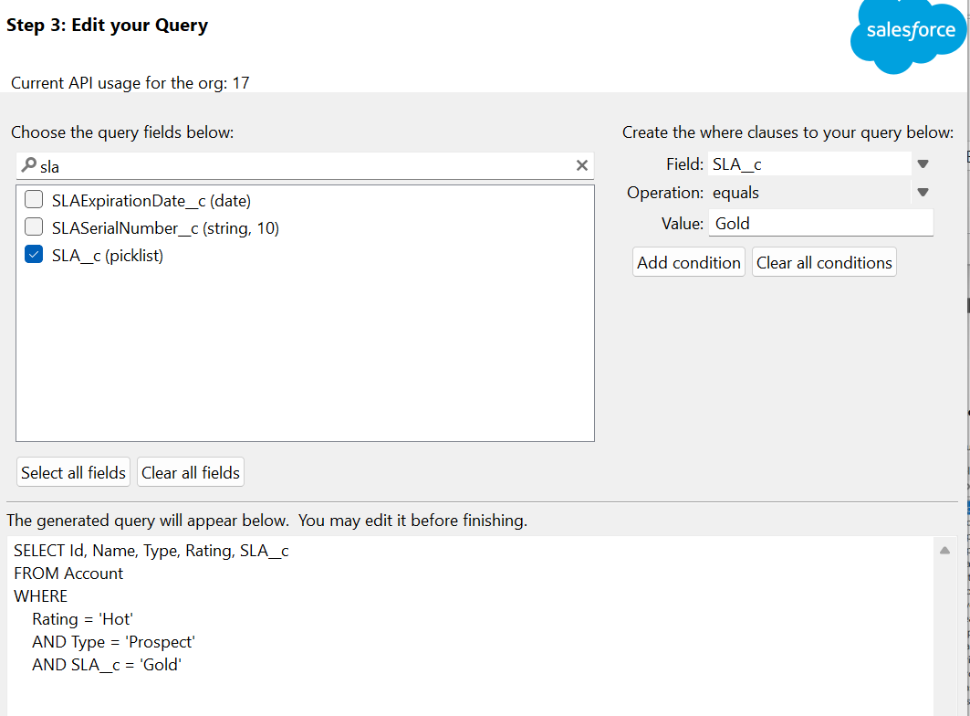
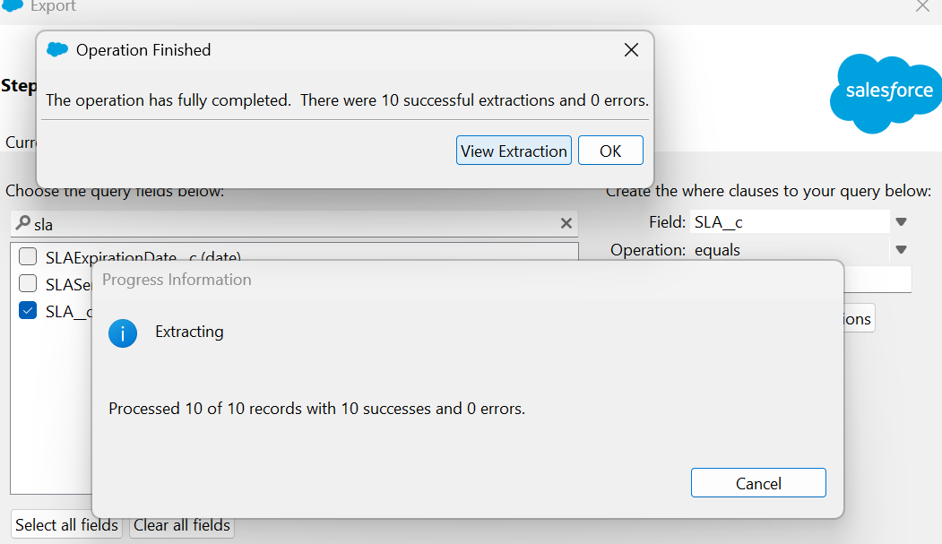
Done
Result-
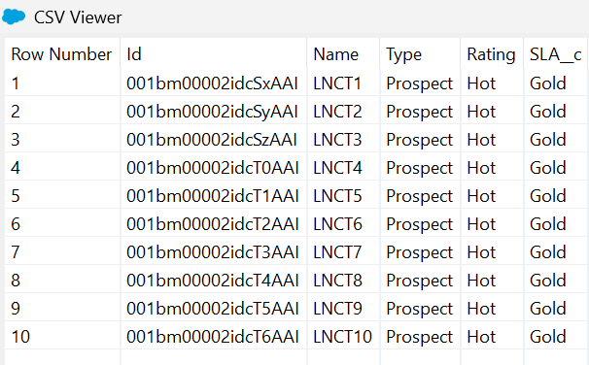

Let’s hard delete-
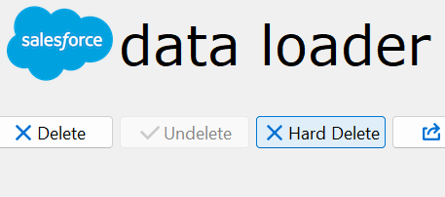
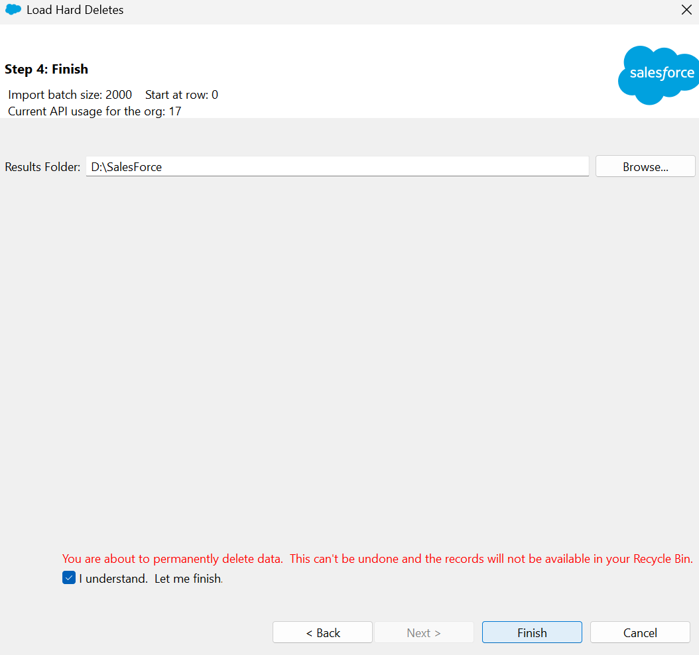
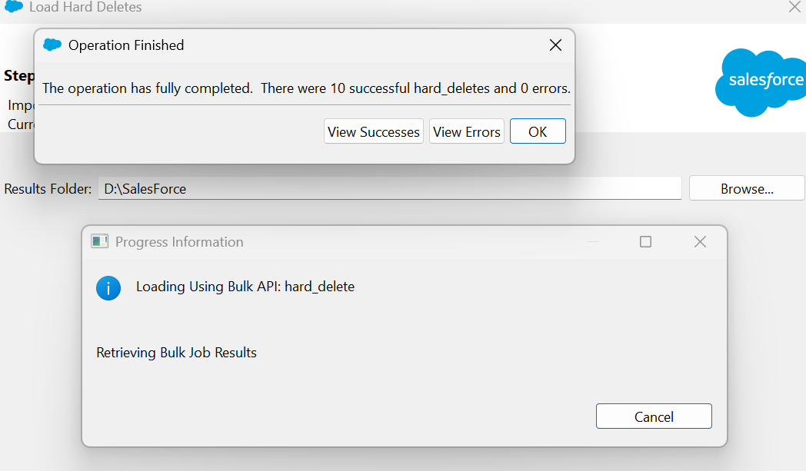
Result-
Its deleted
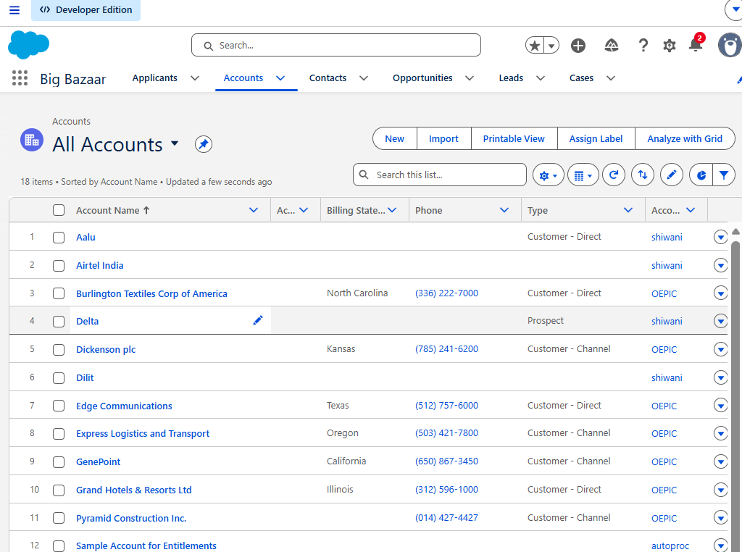

Method 2 for login-
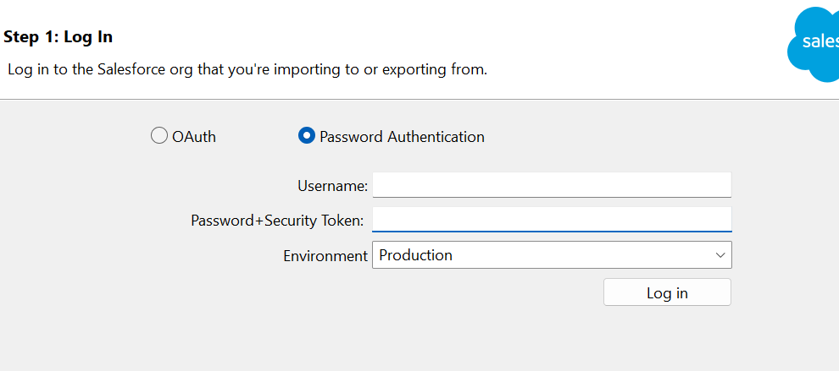

My Settings Personal Rest my security token Reset security token
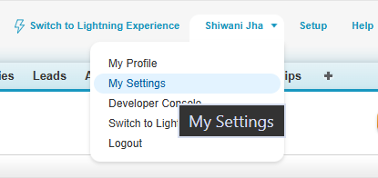
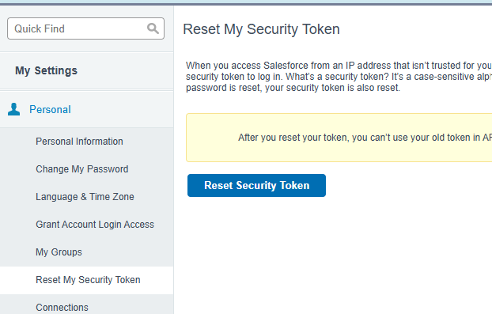

15 digit- salesforce internally work ke liye use this
18 digit – for external use

